1. 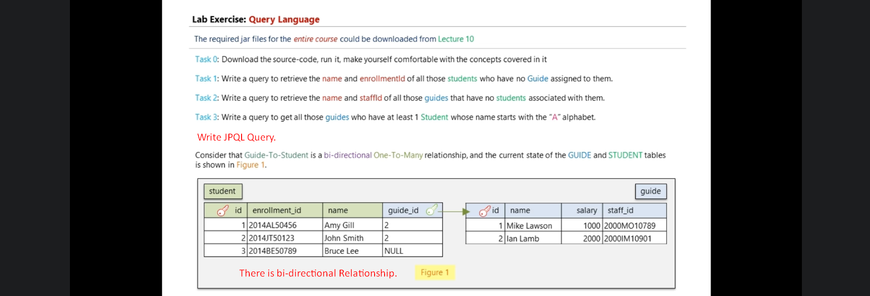
2. 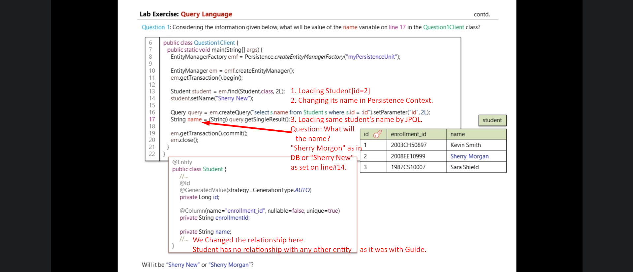
3. To give answer to the above slide, you need to understand flushing.
4. Flushing in JPA happens in 3 different situations.
   1. Flushing at EntityManager.commit()
   2. Flushing at Query Execution: Here Query means JPQL Query.
   3. Flushing At Query Execution With FlushModeType.COMMIT.
5. 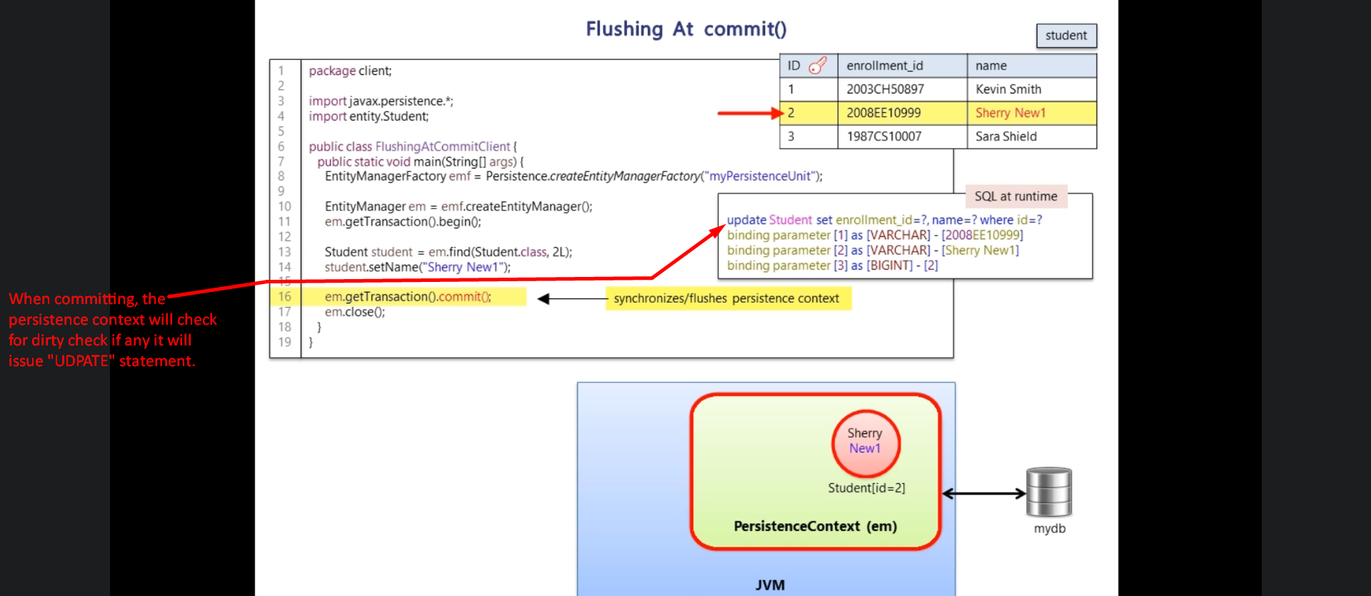
6. 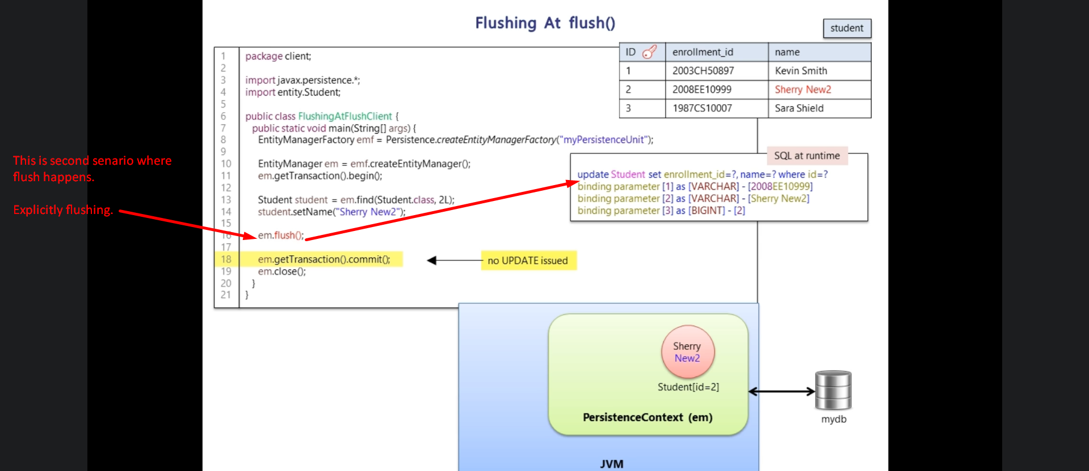
7. 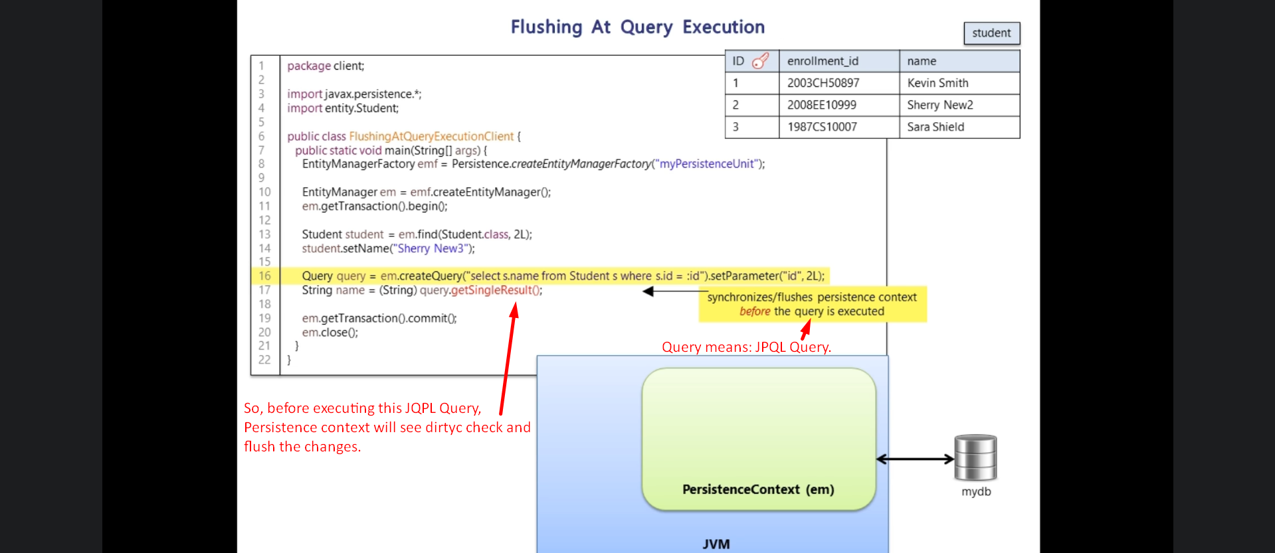
8. 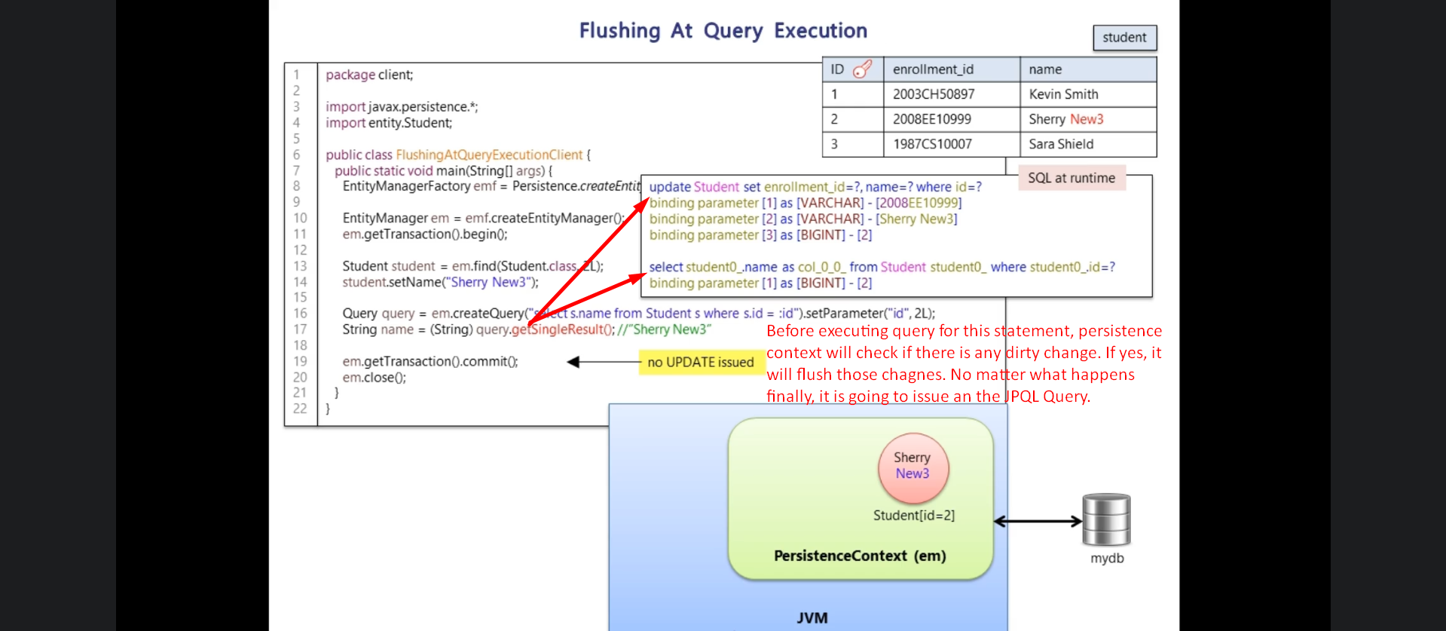
9. 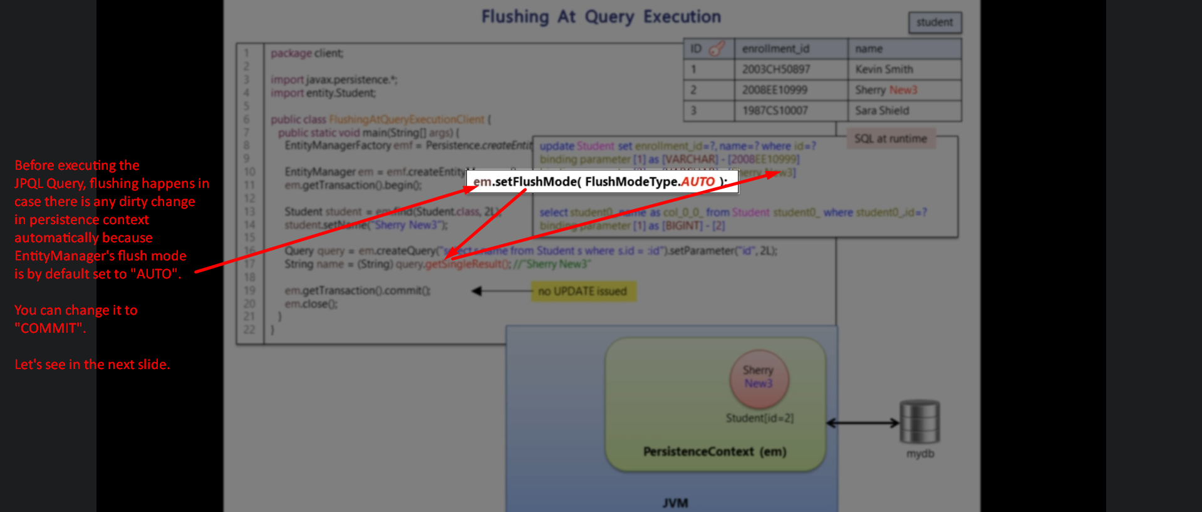
10. 
11. 